**MAI-IDSS Practical Exercise 1 – What Should I Wear? Influence Diagram**

Cole MacLean

March 2, 2016

**Introduction**

In this exercise, we explore the seemingly trivial decision process we all perform daily in deciding what to wear. Using Influence Diagrams, the required information, decisions and influences are modelled to depict the complexity one can encounter when answer the simple question, “What Should I Wear?”.

**Model**

The below figures depict the influence model for the decision process. The targeted objective, named “Optimal Appearance”, is the array of clothing articles in the form of [Socks,Shoes,Pants,Shirt,Hat]. The pre-determined data required to make this decision include:

* Today’s Weather – The current and forecast temperature and precipitation for the day. Used to influence what type of activities to do for the day (ie. Go to the beach if it’s sunny, or stay home and watch Netflix if it’s rainy.)
* Energy Level – Amount of energy and type of mood during the day. Used to influence what type of activities to do for the day (ie. Go to the gym if energetic, or stay home and sleep if tired)
* Routine Schedule – The responsibilities of the day (ie. Classes at school or work at the office)
* Money – The amount of funds available for activities and clothes shopping
* Clean Clothes – The clean clothes currently in the user’s closet
* Dirty Clothes – The dirty clothes current in the user’s laundry basket or floor

With these pre-determined data, the following sub-decisions can be made:

* Today’s Activities – Determine what the daily schedule will be and the types of activities that will occur
* Do Laundry? – Based on clean and dirty clothes, the user decides whether to wash clothes to increase the set of available clothes
* Go Clothes Shopping – Based on available money, clean clothes and whether the user wants to do laundry, the decision to buy new clothes for the day

The results of these decisions provide the values for the 2 uncertainties of Available Clothes and Probability of Meeting Girl. Available Clothes is the set of clothing available to choose from when building the clothing array, and the Probability of Meeting Girl is the statistical likelihood of running into a girl for a given set of activities. This will likely be the most influential node in the Influence Diagram. The decision results are then fed into the “Clothing Decider”, which manages the influences of each article of clothing that is selected influencing the decision of the next article of clothing.

The Clothing Decider contains a dictionary of arrays that contain the order of clothing article selection, given the user’s chose of first article of clothing to pick. For example, if the user’s first article of clothing selected is hat, the order of subsequent clothing decisions is Shoes, Socks, Pants, Shirt.

The model encompasses the decisions required daily for choosing what to wear, and depicts the hidden complexity that such a seemingly simple task can contain.

**What Should I Wear Influence Diagram**

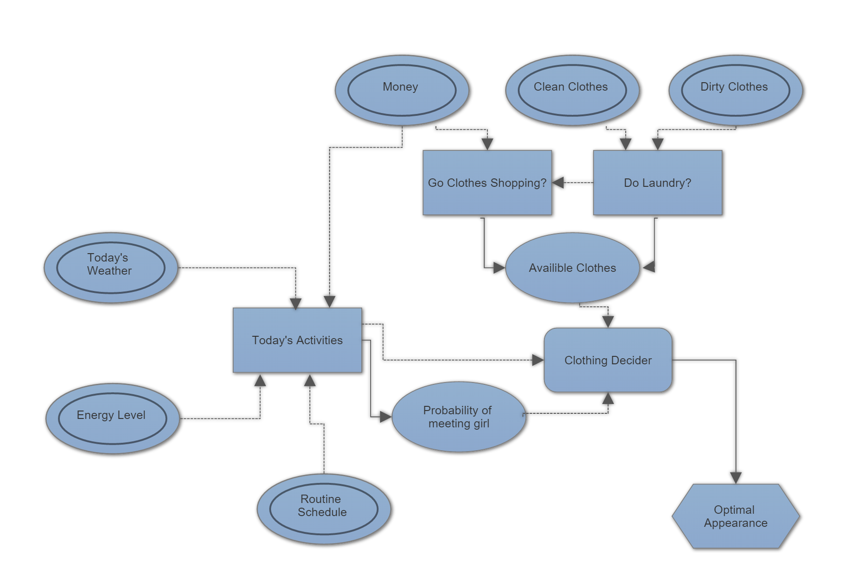

**Clothing Decider Influence Diagram**

